**EXAMLY**

**IDE DOCUMENTATION:**

**Step 1:**

**This is our IDE. It was quite useful to run our programs in a different manner.**

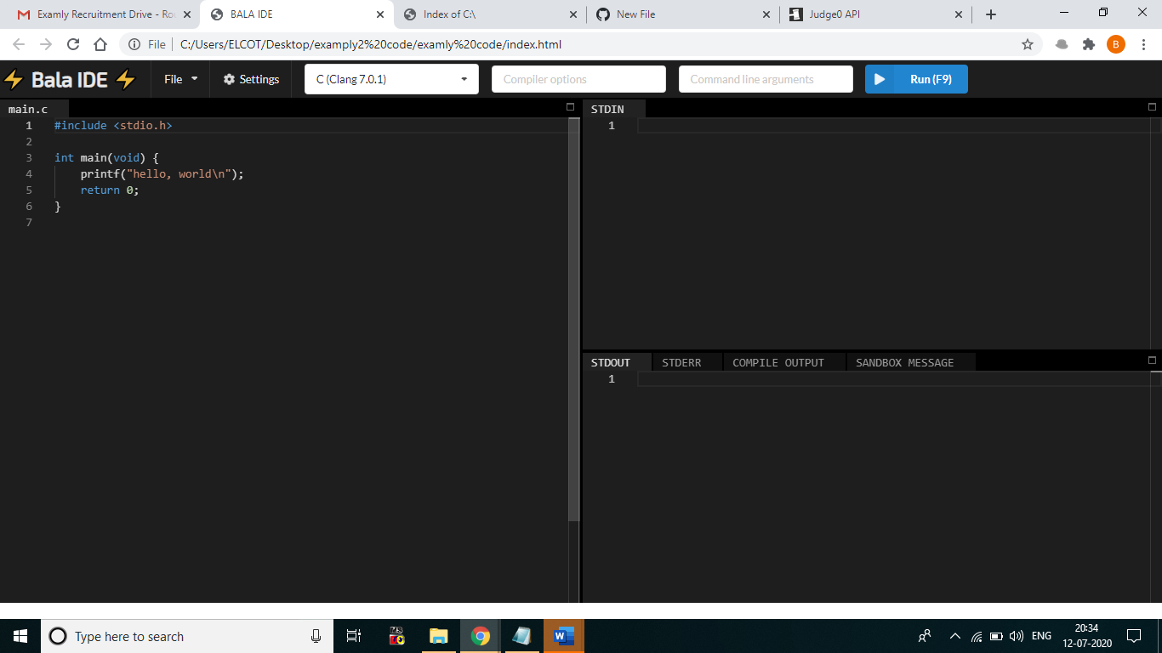

**Step 2:**

**It has a Features to create “New file”.**

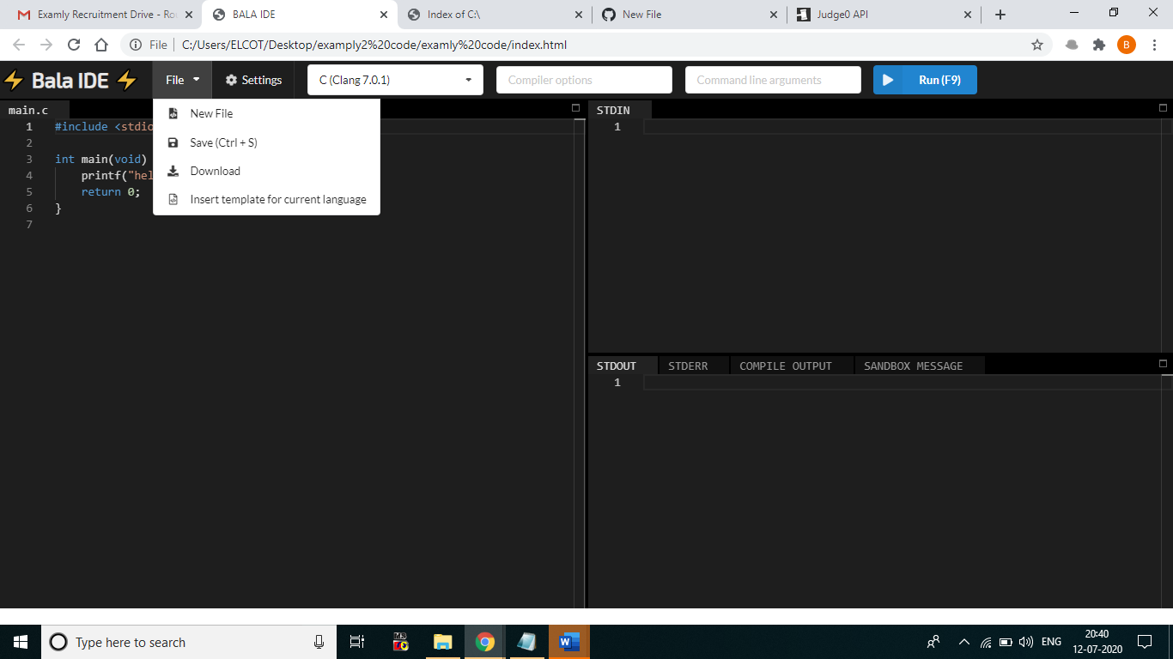

**Step 3:**

**User can able to “Save” the entire program in a local machine as well as can able to download a file.**

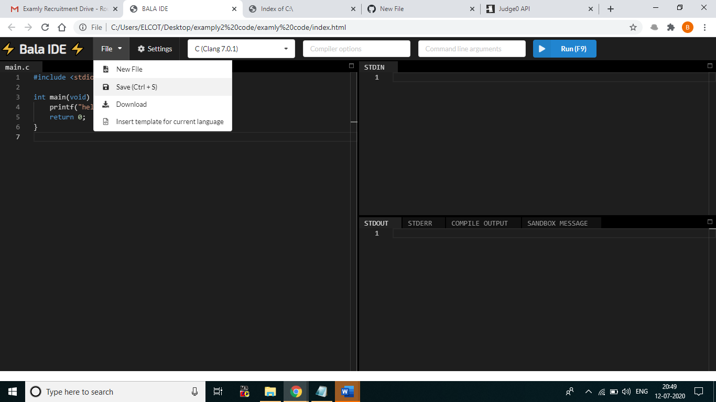

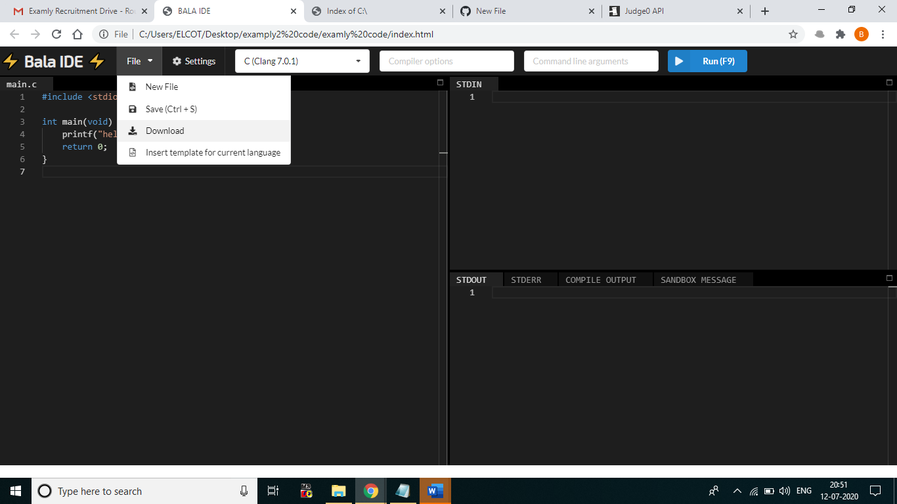

**Step 4:**

**User can able to choose a different Editor mode in a settings menu like Normal, Vim and Emacs.**

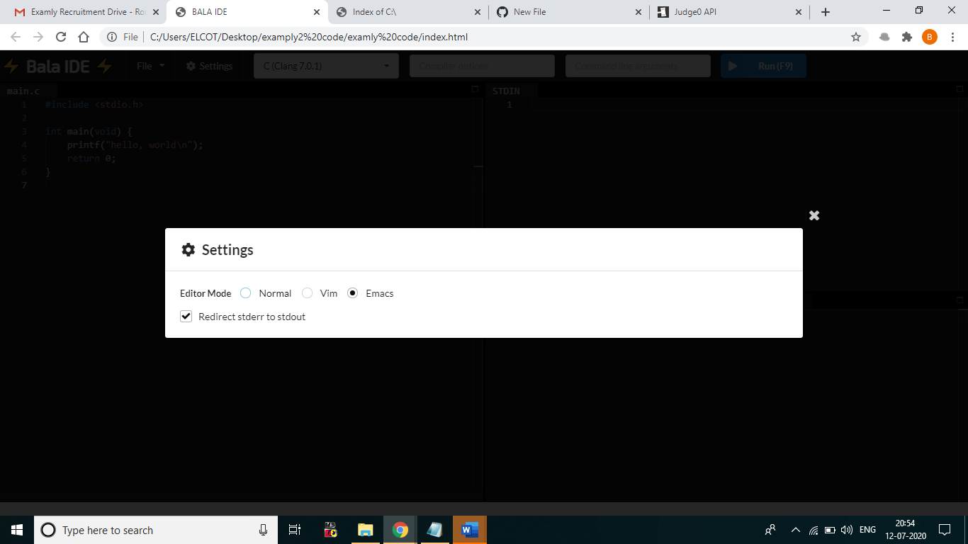

**Step 5:**

**User can switch any other languages in a drop-down (C, C++, Python etc.)**

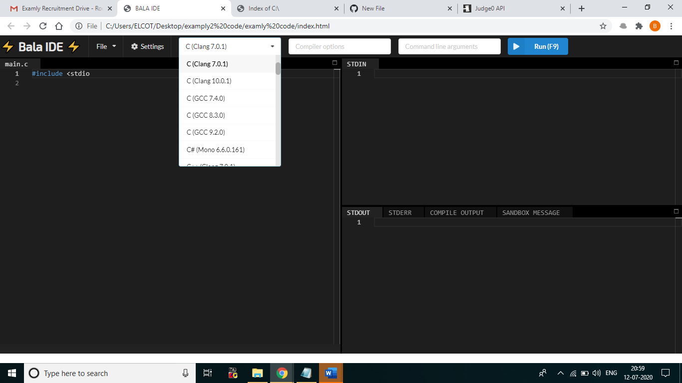

**Step 6:**

**It has a provision to give a “Command line arguments”.**

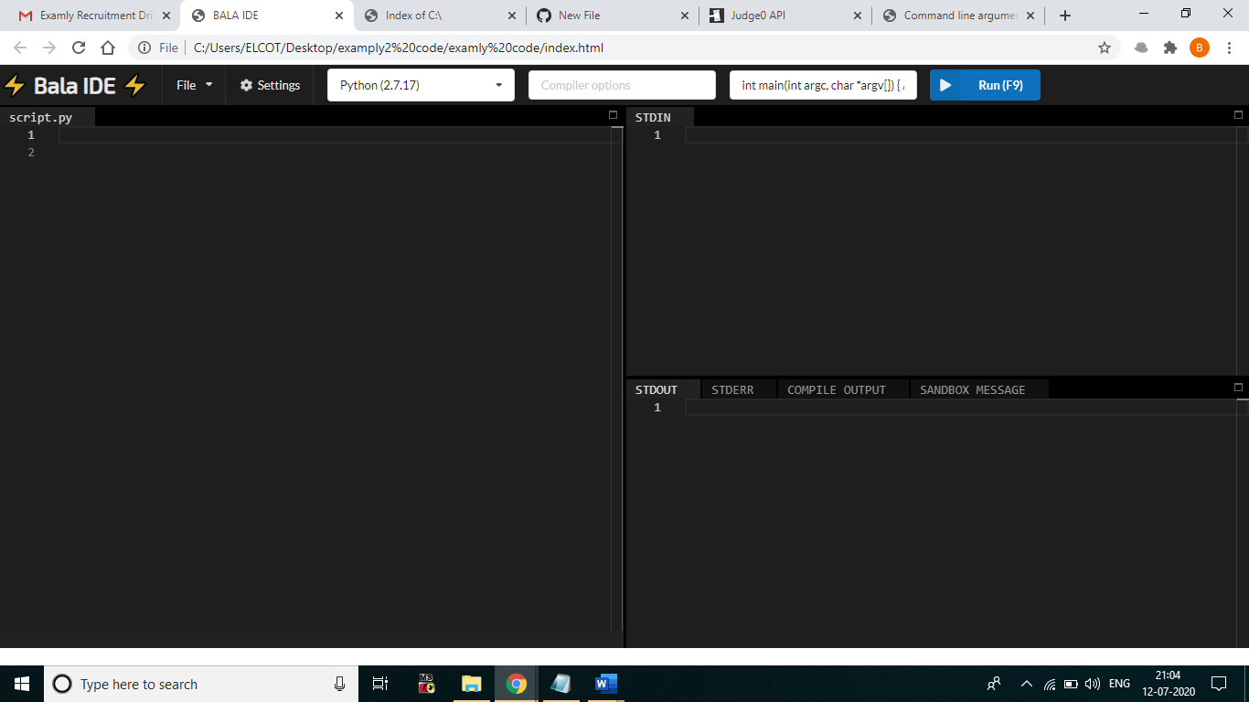

**Step 7:**

**User can write a program in a left side and after that hit a “Run” button will see the result in a bottom right.**

